

Programme Name: ________**BCS HONS**_______________________________________

Course Code: __**CSC 2514**________

Course Name: _______**Web System and Technologies**_____________________________

**Assignment** / Lab Sheet / Project / Case Study No. _**2**___

Date of Submission: ______**8/10/2021**_____________

**Submitted By: Submitted To:**

Student Name**: Dipesh Tha Shrestha** Faculty Name**: Prakash Chandra**

IUKL ID: **041902900028** Department**: LMS**

Semester**: Fourth Semester**

Intake**: September 2019**

1. **With an example, explain the usage of htmlspecialchars() function**

**Answer:** The htmlspecialchars() function converts some predefined characters to HTML entities. It is the in-built function of PHP, which converts all pre-defined characters to the HTML entities. The htmlspecialchars() function accepts an input string ($string) and returns the new string with the special characters converted into HTML entities.

**$string:** This parameter is contains the input string.

**$flags:**  This parameter is used to hold the one or more flags from following, which specify how to handle invalid code unit sequences, quotes, and the used document type.

**encoding:** It is an optional parameter, which defines the encoding which is used when characters are converted. The default value of encoding varies on PHP versions.

**$double_encode:** PHP cannot encode existing HTML entities when the double_encode is turned off. The default is to convert everything.

**Example:**

<?php  
$str = "Ram & 'Sita'";  
echo htmlspecialchars($str, ENT_COMPAT); // Will only convert double quotes  
echo "<br>";

?>

**Output:**

Ram & 'Sita'

1. **Write PHP code to show differences between local and global variables.**

**Answer:**

**Local Variables** A variable declared in a function is considered local; that is, it can be referenced solely in that function.

**Example:**

<?php  
function myTest() {  
  $x = 5; // local scope  
  echo "<p>Variable x inside function is: $x</p>";  
}  
myTest();  
// using x outside the function will generate an error  
echo "<p>Variable x outside function is: $x</p>";  
?>

**Output:**

Variable x inside function is: 5

Variable x outside function is:

**Global variables** are those variables which are declared outside of all the functions or block and can be accessed globally in a program

**Example:**

<?php  
$x = 5; // global scope  
function myTest() {  
  // using x inside this function will generate an error  
  echo "<p>Variable x inside function is: $x</p>";  
}  
myTest();  
echo "<p>Variable x outside function is: $x</p>";  
?>

**Output:**

Variable x inside function is:

Variable x outside function is: 5

**2. For the figure given below:**

**a) Write required HTML and PHP code for the following figure:**

**database.php**

<?php

   $servername='localhost';

   $username='root';

   $password='';

   $dbname = "sunway";

   $conn=mysqli_connect($servername,$username,$password,"$dbname");

     if(!$conn){

         die('Could not Connect MySql Server:' .mysql_error());

       }

?>

**registration1.php**

<!DOCTYPE html>

<html lang="en">

<head>

    <meta charset="UTF-8">

    <meta http-equiv="X-UA-Compatible" content="IE=edge">

    <meta name="viewport" content="width=device-width, initial-scale=1.0">

    <title>Registration</title>

</head>

<body>

   <div>

  <fieldset style= "width: 50%;">

   <legend><b>Enter the student details</b></legend>

       <form action="registration1.php" method="post">

       <table>

           <tr>

               <td>Name</td>

               <td> <input type="text" Name="name"><td>

           </tr>

           <tr>

               <td>Marks obtained</td>

              <td> <input type="text" Name="Subject1" placeholder="Subject1"><td>

              <td> <input type="text" Name="Subject2" placeholder="Subject2"><td>

              <td> <input type="text" Name="Subject3" placeholder="Subject3"><td>

           </tr>

           <tr>

               <td>  </td>

               <td> <input type="submit" name="submit"> </td>

           </tr>

</table>

</form>

  </fieldset>

</div>

<?php

include_once 'database.php';

// $name=$Subject1=Subject2=Subject3="";

if(isset($_POST['submit']))

{

    $name = $_POST['name'];

    $Subject1= $_POST['Subject1'];

    $Subject2= $_POST['Subject2'];

    $Subject3 = $_POST['Subject3'];

    $sql = "INSERT INTO details (name,Subject1,Subject2, Subject3)

    VALUES ('$name','$Subject1','$Subject2','$Subject3')";

    if (mysqli_query($conn, $sql)) {

       echo "New record has been added successfully !";

    } else {

       echo "Error: " . $sql . ":-" . mysqli_error($conn);

    }

    mysqli_close($conn);

}

?>

</body>

</html>

**Output:**

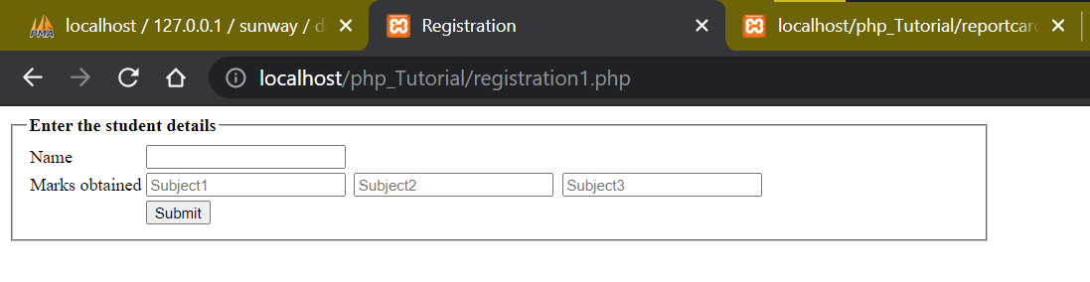

1. **For the fig .1 write required PHP code to collect form data and insert it into database table, with following structure :**

**Creating Database**

Create database sunway;

use sunway;

CREATE TABLE details ( id INT NOT NULL AUTO_INCREMENT , name VARCHAR(100) NOT NULL , subject1 DECIMAL(6,2) NOT NULL , subject2 DECIMAL(6,2) NOT NULL , subject3 DECIMAL(6,2) NOT NULL , PRIMARY KEY (id))

**Output:**

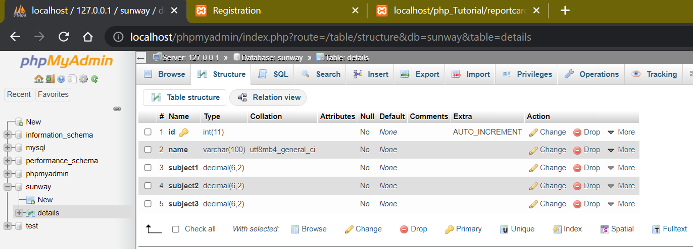

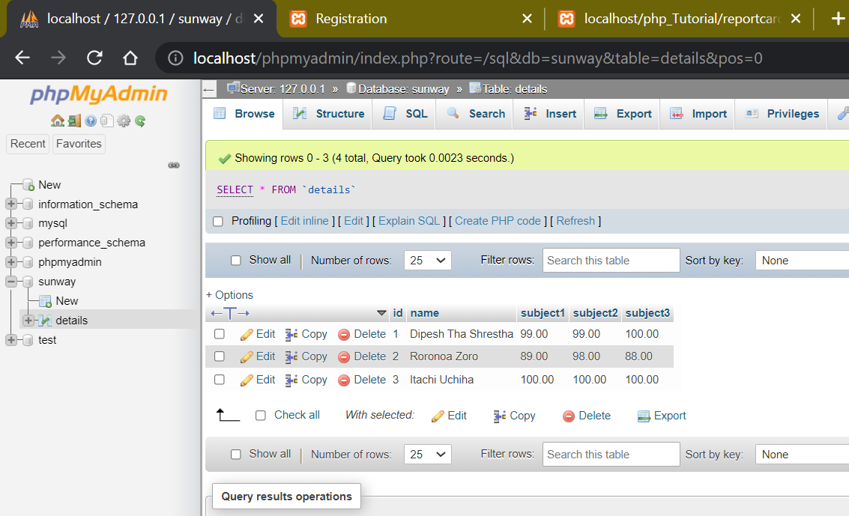

1. **Fetch the result from the table in fig. 2 and display the result as shown in figure below: NOTE: use function to calculate average marks**

**reportcard.php**

<html>

   <body>

   <?php

   $conn=mysqli_connect("localhost","root","","sunway");

   $sql="SELECT *from details";

   $result=mysqli_query($conn,$sql) or die("Query Unsuccessful");

   if(mysqli_num_rows($result)>0)

   {

   ?>

   <form > <fieldset style="width: 50%;">

   <h3>Student Report Card</h3>

       <table border="1" cellpadding="10" cellspacing="0">

           <tr>

               <th>Name</th>

               <th colspan="3">Subjects</th>

               <th>Average Mark</th>

           </tr>

           <?php

           $i=0;

           while($row=mysqli_fetch_array($result))

           {

               $i=$i+1;

            ?>

           <tr>

               <td>

                   <?php echo $row["name"]; ?>

        </td>

            <td style="padding-left: 30px;"> <?php echo $row["subject1"]; ?></td>

             <td style="padding-left: 30px;"><?php echo $row["subject2"]; ?></td>

            <td style="padding-left: 30px;"><?php echo $row["subject3"]; ?></td>

        <td>

                   <?php

                   $s1=$row["subject1"];

                   $s2=$row["subject2"];

                   $s3=$row["subject3"];

                   $avg=($s1+$s2+$s3)/3;

                   echo $avg;

                   ?>

               </td>

           </tr>

           <?php } ?>

       </table>

       <?php } ?>

       </fieldset>

    </form>

   </body>

</html>

**Output:**

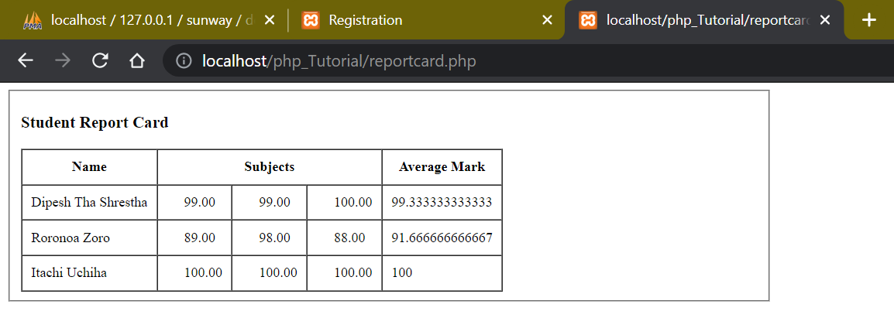

***Thank You***